Parents/Caregivers
During the upcoming School Newsletters and Social Media pages Gilgandra Public School will be introducing you to our EDI policy.
To begin with:
What is EDI?
(Explicit Direct Instruction)
‘Kids are involved in their learning, understand how they are being taught, and are able to reflect on their learning'.
There are six 'givens' (expectations/ assumptions) in the Fleming Model classroom:
1) Positive Relationships
2) High Expectations
3) Presentation
4) Correction
5) Display
6) Setting the Tone (upholding classroom order and rules/ requirements)
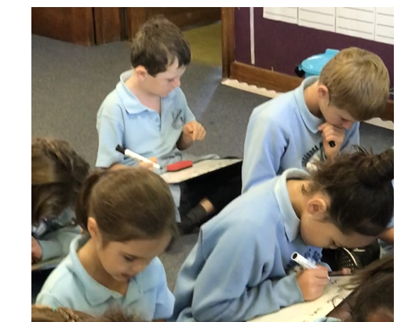
Watch this space for photos, videos and information on EDI in our school.

