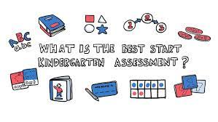

Dear Parents/caregivers,
On Monday 4th April at 2:30 pm you are invited to visit your child’s classroom. They will be showcasing how Explicit Direct Instruction is taught at our school. Also, this is an opportunity to collect and understand how Best Start impacts your child’s learning in Literacy and Numeracy.
We look forward to your visit.

Sally Jordison Terri-Lee Naden Jade Moore
APC&I Teacher Teacher

