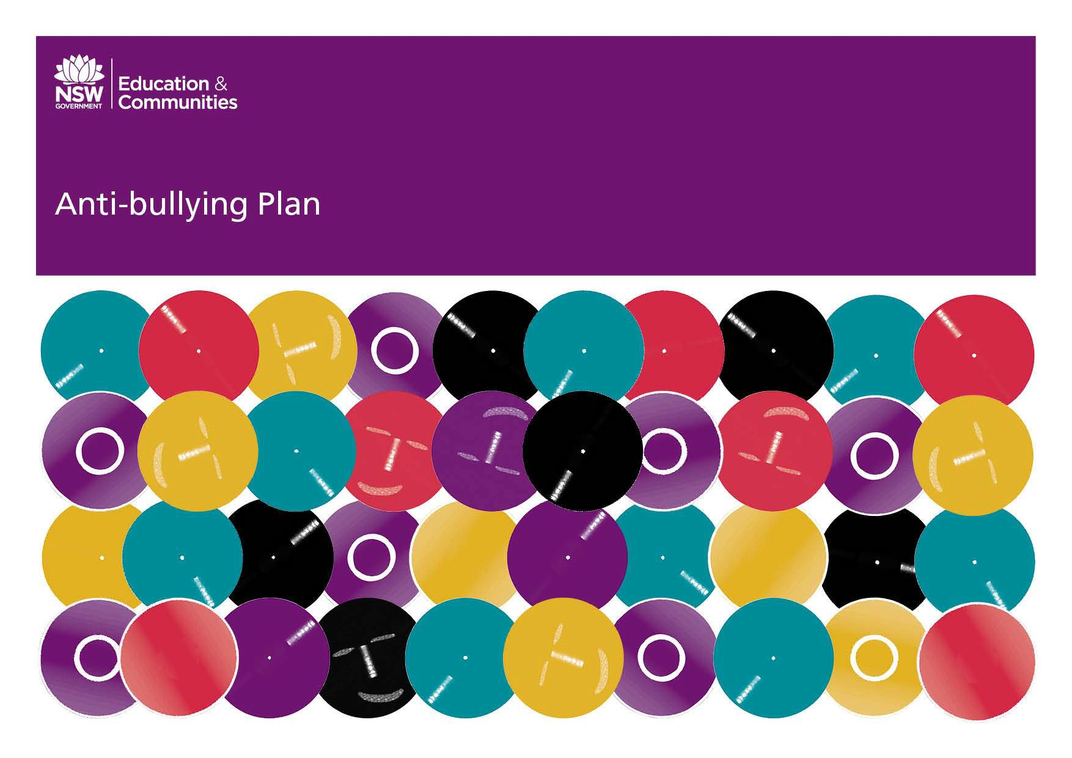

Gilgandra Public School

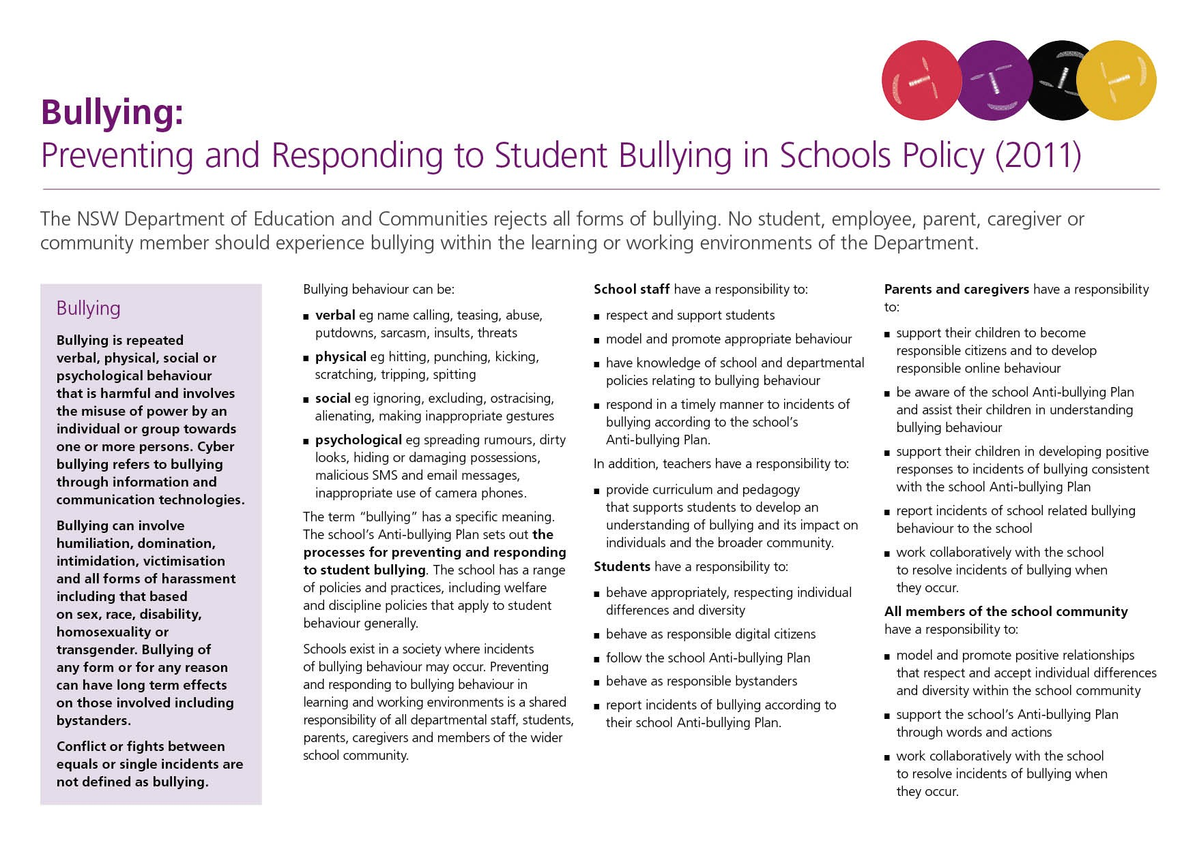

TOurhe Anti-SBulclyhooling PlanA– NntSWi-DBeparutlmlyenitnofgEducatPlaionn and Communities

Our School Anti-Bullying Plan
This plan outlines the processes for preventing and responding to student bullying in our school and reflects the Bullying: Preventing and Responding to Student Bullying in Schools Policy of the New South Wales Department of Education and Communities.
.

Statement of purpose

The aim of this policy is to ensure that staff, parents and students of Gilgandra Public School will work together to create a safe, caring and productive learning community that supports the rights of all students to learn and all teachers to teach. We take bullying seriously and will intervene in a way to deal with incidents of bullying in a timely and consistent fashion.

Protection
Bullying is repeated verbal, physical, social or psychological behavior
that is harmful and involves the misuse of power by an individual or
group towards one or more persons. Cyber bullying refers to bullying
through information and communication technologies.

Bullying can involve humiliation, dominations, intimidation, victimisation,
and all forms of harassment including that based on sex, race,
disability, homosexuality or transgender.
Bullying of any form or for any reason can have long-term effects on those
involved, including bystanders.

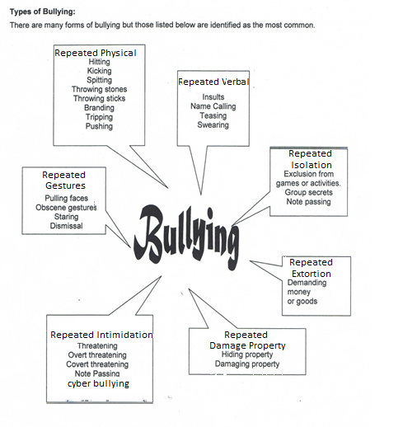

Responsibilities and delegations

Schools/Principal have a responsibility to:

- Develop an Anti-bullying Plan through consultation with parents, caregivers, students and the community, which clearly identifies both the behaviours that are unacceptable and the strategies for dealing with bullying in the classroom and playground

- Inform students, parents, caregivers and the community about the School Discipline Code and Anti-bullying Plan

- Provide students with strategies to respond appropriately to incidents of bullying behaviour, including responsibilities as bystanders and observers

- Provide parents and caregivers and students with clear information on strategies that promote appropriate behaviour, and the consequences for inappropriate behaviour

- Communicate to parents and caregivers that they have an important role to play in resolving incidents of bullying behaviour involving their children

- Follow up complaints of bullying, harassment and intimidation

Students have a responsibility to:

- Behave appropriately, respecting individual differences and diversity
- Follow the school Anti-bullying Plan
- Respond to incidents of bullying according to their school Anti-bullying Plan

Parents and caregivers have a responsibility to:
- Support their children in all aspects of their learning
- Be aware of the school Anti-bullying Plan and assist their children in understanding bullying behaviour
- Support their children in developing positive responses to incidents of bullying consistent with the school Anti-bullying Plan
- Support all students of the school to deal effectively with bullying through the strategies of the Anti-bullying Plan
- Explain the understandings the school has developed about the individual and shared responsibilities of students, parents, caregivers and teachers in preventing and responding to bullying behaviour.

Implementation Strategies
- Parents, teachers, students and the community will be aware of the school’s position on anti- bullying. In order for the anti- bullying message to permeate at the School’s culture information is provided for students, parents, caregivers and teachers to identify bullying behavior.

Prevention
Gilgandra Public School will embed anti-bullying messages into curriculum areas in every year level.

- PBL lessons involving Respect and Safety
- Interpersonal Skills Units taught in PD/PD/Health
- Specific lessons targeting bullying.
- Classroom and playground expectations and routines applied consistently
- Active supervision of students in the classroom and in the playground.
- Modelling of appropriate problem solving behaviour and conflict management.
- Active intervention when bullying behavior occurs.
- Professional Learning provided to staff on Anti-Bullying strategies and programs.
- Drug Education and Child Protection programs
- Life Education program
- Active Learning Support Team

Early Intervention
For students who are identified as being at risk of developing long-term difficulties with social relationships and those students who are identified at or after enrolment as having previously experienced bullying or engaged in bullying behaviour the following are interventions that may be implemented.
- Class anti bullying lessons
- Existing behavior/ consequence chart
- PBL lessons involving Respect and Safety
- Targetted Social Skills groups
- Use of School counsellor and Chaplain

School Executive, Learning Support Team or class teachers may implement a range of interventions applicable to the type of bullying incident. Interventions need to be matched to the type of bullying.

Response
Gilgandra Public School responds to all behavioural and bullying incidents setting out clear behaviour standards through the PBL program and using consequences to prevent and deter the students from repeating their behaviour. Consequences could include detention, loss of privileges and even suspension. The incident of bullying will be investigated and dealt with quickly and consistently.

The interventions that will be implemented at Gilgandra Public School to support any student who has been affected by, engaged in or witnessed bullying behavior are:
Class anti bullying lessons- Gilgandra Public School students will participate in lessons aimed at reducing the incidence of bullying at school. These lessons will come from a number of sources;
- Bullying No Way,
- PD/H/PD Syllabus
- Bullying Prevention in Positive Behaviour Support
- Bullying a Whole School Approach
- Bullying-RIC Publications
Processes for dealing with Bullying will include
- Following the existing behaviour/ consequence chart
- Discussions with staff, students and parents
- PBL lessons involving Respect and Safety will be modelled and taught
- Mediation
- Outside Agency Support as appropriate
- School counsellor/chaplain as appropriate
Gilgandra Public School parents will be provided with regular updates, within the bounds of privacy legislation, in the school newsletter about ways to deal with bullying at school. Specific parents will be contacted as necessary if their child is involved in a bullying incident.

In the case of serious or security incidents Gilgandra Public School will adhere to the Department of Education and Communities procedures to report incidents involving assaults, threats, intimidation or harassment to the police.
Gilgandra Public School will contact the Child Wellbeing Unit or Community Services when deemed appropriate in a bullying matter.
Gilgandra Public School will adhere to the Complaints Handling Policy which establishes the standard approach to resolving complaints, including complaints about the way a reported incident of bullying has been managed.
Gilgandra Public School records all behavioural and bullying incidents on the STARS computer program. At PBL meetings, STARS data is presented for analysis and followed-up with students, parents and teachers. Identified students will be dealt with according to the PBL Consequence Chart and referred to School Learning Support Team.
Gilgandra Public School will promote and publicise the Anti-bullying Plan through the newsletter, parent meetings and the school’s website to the school community.
The Anti-Bullying Plan will be evaluated regularly at Learning Support Team and Executive meetings. Staff meetings will provide time for staff to monitor and evaluate.
Gilgandra Public School will conduct a review of the Anti-bullying Plan every three years with the school community. The process will take the form of a student, staff and parent survey to collect data on current procedures. Data will be analyzed by the team and the Anti-Bullying Policy strategies will be amended as required.

Contacts
Marty Paice - Police School Liaison Police officer (SLP)

Kids Helpline - Ph. 1800 551 800 or www.kidshelp.com.au

Brian Carr-Aboriginal Liason Officer

Patricia Howard-Principal

Janine Hazelton-Assistant Principal Leanne Morris-Assistant Principal
Rebecca Rogers-Teacher
Chantel Chandler-Parent and P&C Representative
Anneke Aro- Parent/ Chaplain
Deidre Naden- AECG Representative

School contact information
Gilgandra Public School

School Address: Wamboin Street Gilgandra Ph: 0268472043
Fax: 0268472304

Email: gilgandra-p.school@det.nsw.edu.au Web: www.gilgandra-p.schools.nsw.edu.au

