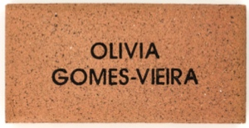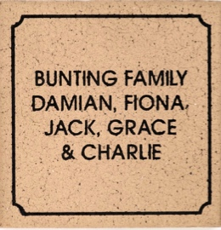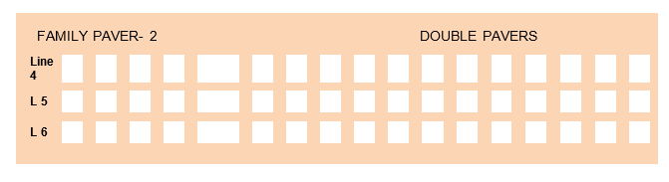

In honour of your generous contribution, a personalised engraved paver(s) of your creation will be placed in Gilgandra Public Schools NEW outdoor learning area.

**OPTION 1 $35**

**Standard Name**

**(up to 3 lines of text)**

**TICK**

**OPTION 2 $85**

**Double Name**

**(up to 6 lines of text)**

**TICK**

Gilgandra Public School along with the Student Representative Council would like to invite families and friends both past and present to take part in our engraved paver fundraiser.  Pavers can be engraved with a family or student name and date or with a simple hand drawing. The pavers will be laid in our new outdoor learning area for students to access in play time, class time or with small groups. Please complete the forms attached below and return with payment to the school. Thank you

**OFFER CLOSES September 21st 2020.**

**PLEASE COMPLETE THE PAVER DETAILS ON THE REAR OF THIS FORM**

|  |  |  |  |  |  |  |
| --- | --- | --- | --- | --- | --- | --- |
| **CONTACT DETAILS AND PAYMENT OPTIONS :** | | | | | | |
| **Name** | | | **Phone** | | **Donation Amount** | |
|  | | |  | | $ | |
| **Payment Options** (please circle) **: CASH CHEQUE CARD** | | | | | | |
| Cheques to be made out to : | | {Account Details} | | | | |
| Credit Card Payments Option : Credit Card Type (please circle) Visa / Master Card | | | | | | |
| Name on Credit Card : |  | | | | | |
| Credit Card Number | | | | Expiry Date | | CRC Number |

/

**FUNDRAISING FOR A BETTER FUTURE**

|  |  |  |  |  |  |  |  |  |  |  |  |  |  |  |  |  |  |  |  |  |  |  |  |  |  |  |  |  |  |  |  |  |  |  |
| --- | --- | --- | --- | --- | --- | --- | --- | --- | --- | --- | --- | --- | --- | --- | --- | --- | --- | --- | --- | --- | --- | --- | --- | --- | --- | --- | --- | --- | --- | --- | --- | --- | --- | --- |
| **Line 1** |  |  |  |  |  |  |  |  |  |  |  |  |  |  |  |  |  |  |  |  |  |  |  |  |  |  |  |  |  |  |  |  |  |  |
|  |  |  |  |  |  |  |  |  |  |  |  |  |  |  |  |  |  |  |  |  |  |  |  |  |  |  |  |  |  |  |  |  |  |  |
| **L2** |  |  |  |  |  |  |  |  |  |  |  |  |  |  |  |  |  |  |  |  |  |  |  |  |  |  |  |  |  |  |  |  |  |  |
|  |  |  |  |  |  |  |  |  |  |  |  |  |  |  |  |  |  |  |  |  |  |  |  |  |  |  |  |  |  |  |  |  |  |  |
| **L3** |  |  |  |  |  |  |  |  |  |  |  |  |  |  |  |  |  |  |  |  |  |  |  |  |  |  |  |  |  |  |  |  |  |  |

DOUBLE PAVERS

FAMILY PAVER- 2

|  |  |  |  |  |  |  |  |  |  |  |  |  |  |  |  |  |  |  |  |  |  |  |  |  |  |  |  |  |  |  |  |  |  |  |
| --- | --- | --- | --- | --- | --- | --- | --- | --- | --- | --- | --- | --- | --- | --- | --- | --- | --- | --- | --- | --- | --- | --- | --- | --- | --- | --- | --- | --- | --- | --- | --- | --- | --- | --- |
| **Line 1** |  |  |  |  |  |  |  |  |  |  |  |  |  |  |  |  |  |  |  |  |  |  |  |  |  |  |  |  |  |  |  |  |  |  |
|  |  |  |  |  |  |  |  |  |  |  |  |  |  |  |  |  |  |  |  |  |  |  |  |  |  |  |  |  |  |  |  |  |  |  |
| **L2** |  |  |  |  |  |  |  |  |  |  |  |  |  |  |  |  |  |  |  |  |  |  |  |  |  |  |  |  |  |  |  |  |  |  |
|  |  |  |  |  |  |  |  |  |  |  |  |  |  |  |  |  |  |  |  |  |  |  |  |  |  |  |  |  |  |  |  |  |  |  |
| **L3** |  |  |  |  |  |  |  |  |  |  |  |  |  |  |  |  |  |  |  |  |  |  |  |  |  |  |  |  |  |  |  |  |  |  |

Single PAVERS

SINGLE PAVER- 1

ENGRAVING DETAILS – MAX 17 CHARACTERS PER LINE

Please print clearly using ALL CAPITAL. Max 3 lines per paver.

Each box represents a character (letter, number, punctuation mark or space). No hand drawings.

**OPTION 1** – COMPLETE UP TO 3 LINES IN single paver 1

**OPTION 2** - COMPLETE UP TO 6 LINES on family paver 2

**INSTRUCTIONS FOR COMPLETING THIS FORM**